27-2-2024

Cristian Valentin v Anghel

M03UF3

Fonaments de gestió de fitxers

Manipulació de fitxers

Index

Abstract 2

Diagrama de flujo 2

Codigo 2

Display 2

# Abstract

On this project I had to get the details like the pixels, height and color from a Gif that you saved in your same Project. Ask the user how is the name called and find it. Also the option to make an additional same file.

# Diagrama de flujo

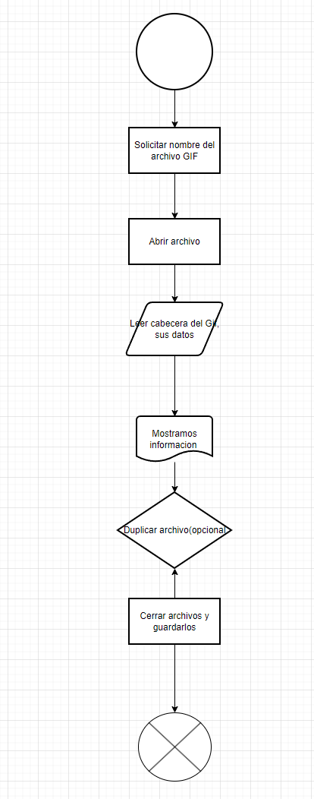

# Código

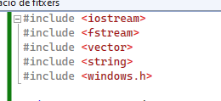

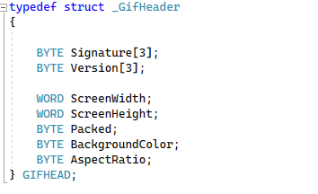

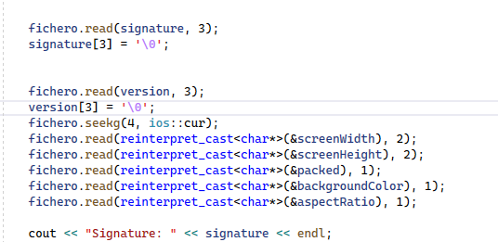

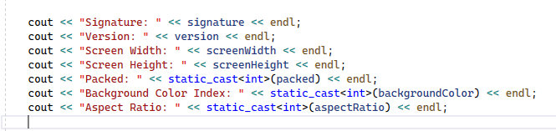

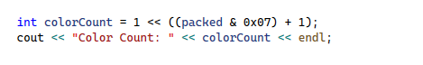

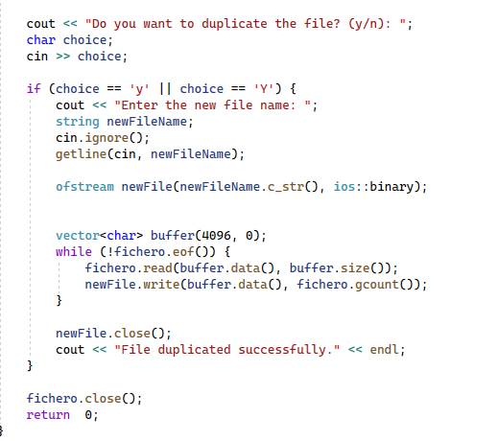

# Display

# 